Deontology

Definition for layperson:
In the following we want to ask you to evaluate the [Stratospheric Aerosol Injection] technology regarding the possibility that it violates central principles or duties.

Deontology is concerned with the possible violation of central principles or duties:
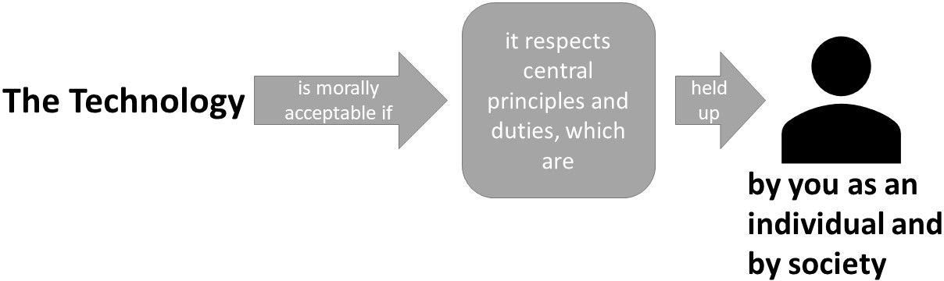
A technology is morally acceptable if it respects basic principles and duties. These basic principles are held up by you as a free and rational acting person. Your principles are oriented at the guiding statement, that "You should act the way you want others to act". When interacting with the technology the possible violation of your principles and not the outcomes and consequences are of central importance.

Utilitarianism

Definition for layperson:
In the following we want to ask you to evaluate the [Stratospheric Aerosol Injection] technology regarding the consequences for society.

Utilitarianism is concerned with the consequences for society:

A technology is morally acceptable if it leads to the best outcomes and consequences for SOCIETY, if you imagine society interacting with the technology. By interacting with the technology, society aims to maximize the overall "goodness" by increasing the utility, decreasing harm or leading to a better world.

Hedonism

Definition for layperson:
In the following we want to ask you to evaluate the [Stratospheric Aerosol Injection] technology regarding the consequences for you personally.

Hedonism is concerned with the consequences for you personally:

A technology is morally acceptable if it increases pleasure, wellbeing or promotes a good life for YOU, if you imagine interacting with the technology. By interacting with the technology in an instrumental way you can affect your pleasure, wellbeing or your personal goals.

Virtue ethics

Definition for layperson:
In the following we want to ask you to evaluate the [Stratospheric Aerosol Injection] technology regarding the moral standards of the person who has developed this technology.

Virtue ethics is concerned with the moral standards of the developer of the technology:
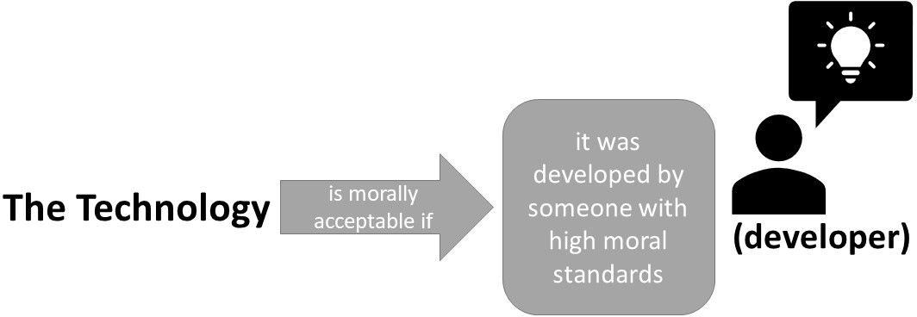
A technology is morally acceptable if it has been developed by someone who has the character and ability to recognize what is morally required. The developer is an upright person with high moral standards, who has developed the technology considering her/his values.

Contractualism

Definition for layperson:
In the following we want to ask you to evaluate the [Stratospheric Aerosol Injection] technology in terms of whether it disregards or works against implicit conventions upon which our society generally relies.

Contractualism whether implicit conventions upon which our society generally relies are disregarded or violated:

A technology is morally acceptable if it does not disregard or work against implicit moral conventions, which have been formed in mutual consensus. To not break moral conventions is in the best interest of all members of a society. Life, for example, in a state where there is “war of all against all” would be too insecure and harmful.

Relativism

Definition for layperson:
In the following we want to ask you to evaluate the [Stratospheric Aerosol Injection] technology regarding the possibility that the ethical evaluation differs between groups of people.

Relativism is concerned with the possibility if the ethical evaluation differs between groups of people:
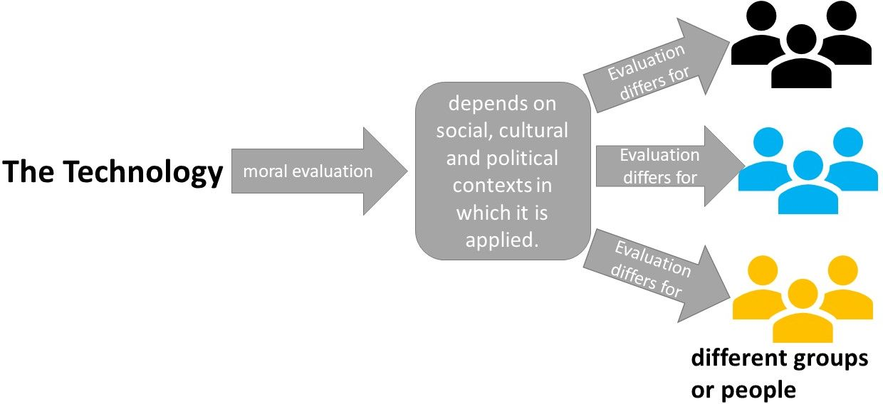
The acceptability of a technology depends on the social, cultural and political contexts in which it is applied. These different contexts influence the standards and procedures of justifying using or implementing a technology.

